Request for Proposal (RFP)

Oracle Fusion Cloud Applications Implementation

Manufacturing Enterprise Resource Planning Solution

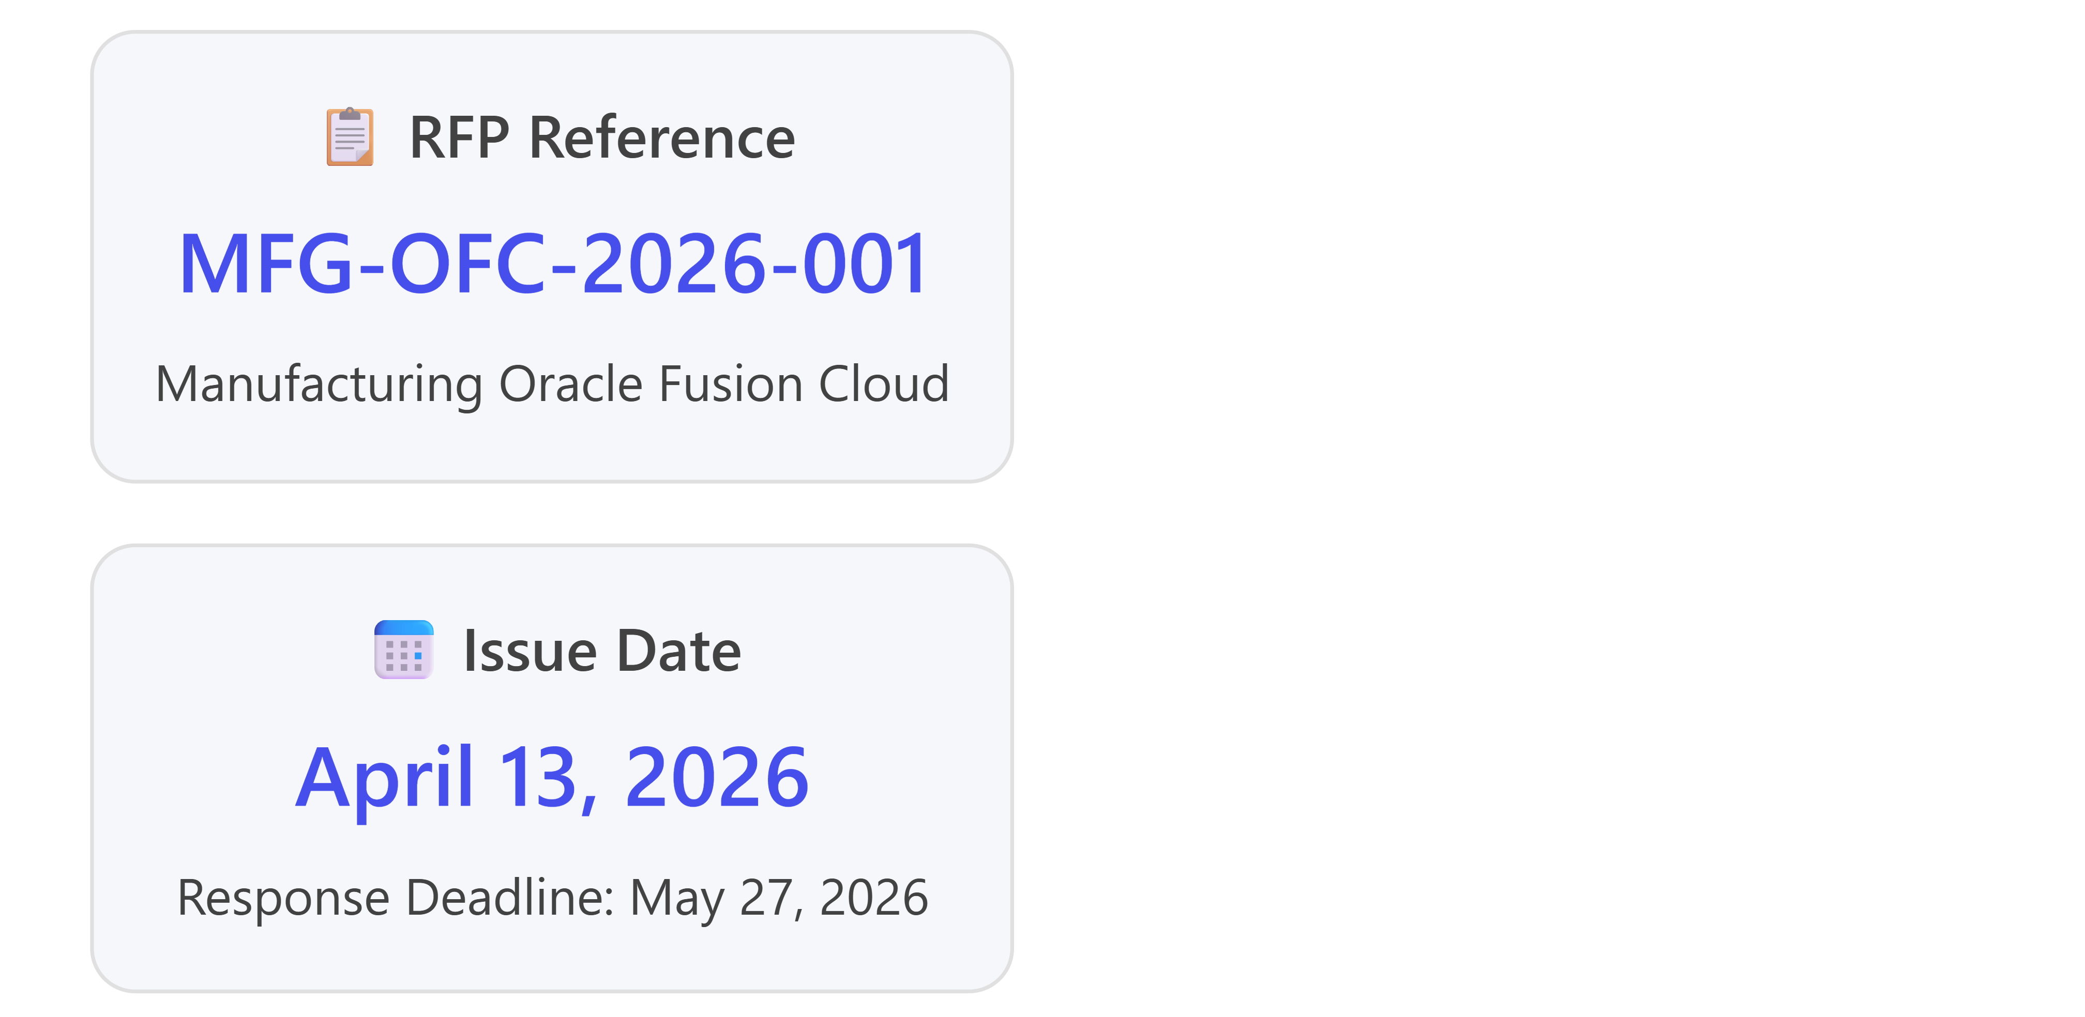

1. Executive Summary

1.1 Purpose
This Request for Proposal (RFP) seeks qualified vendors to provide a comprehensive cloud-based Enterprise Resource Planning (ERP) solution specifically designed for manufacturing operations. The selected solution must address critical business challenges including supply chain volatility, production inefficiencies, disconnected finance and operations systems, and the need for real-time data visibility across the enterprise.

1.2 Company Background
[Client Company Name] is a manufacturing organization facing the challenges common to the industry in 2026, including:
- Supply Chain Disruptions: Material shortages, shipping delays, and price fluctuations creating planning difficulties
- Production Inefficiencies: Manual scheduling, unintegrated manufacturing execution systems, and lack of real-time shop floor visibility
- Disconnected Systems: Finance and production teams using different systems, causing reconciliation delays and unreliable forecasts
- Aging IT Infrastructure: On-premise ERPs creating risks related to downtime, security, compliance, and scalability
We are seeking a modern, cloud-native ERP solution that will transform our operations and position us for sustainable growth.

1.3 Oracle Fusion Cloud Applications - Strategic Fit
Based on preliminary research, Oracle Fusion Cloud Applications represents a compelling solution for manufacturing enterprises. Key alignment factors include:
- Unified Data Platform: Single database architecture eliminating data synchronization issues and 3am batch jobs
- Cloud-Native Architecture: Built specifically for cloud deployment, not retrofitted from on-premise systems
- Manufacturing-Specific Capabilities: Work order management, production scheduling, BOM/routing management, and shop floor control
- Embedded AI Capabilities: 50+ AI agents in Oracle 26A release for procurement, cash flow forecasting, and compliance monitoring
- Rapid Implementation: 6-12 month implementation timeline versus 12-24 months for competitor solutions

2. Business Requirements

2.1 Current State Challenges
Our organization faces the following critical operational pain points that must be addressed:
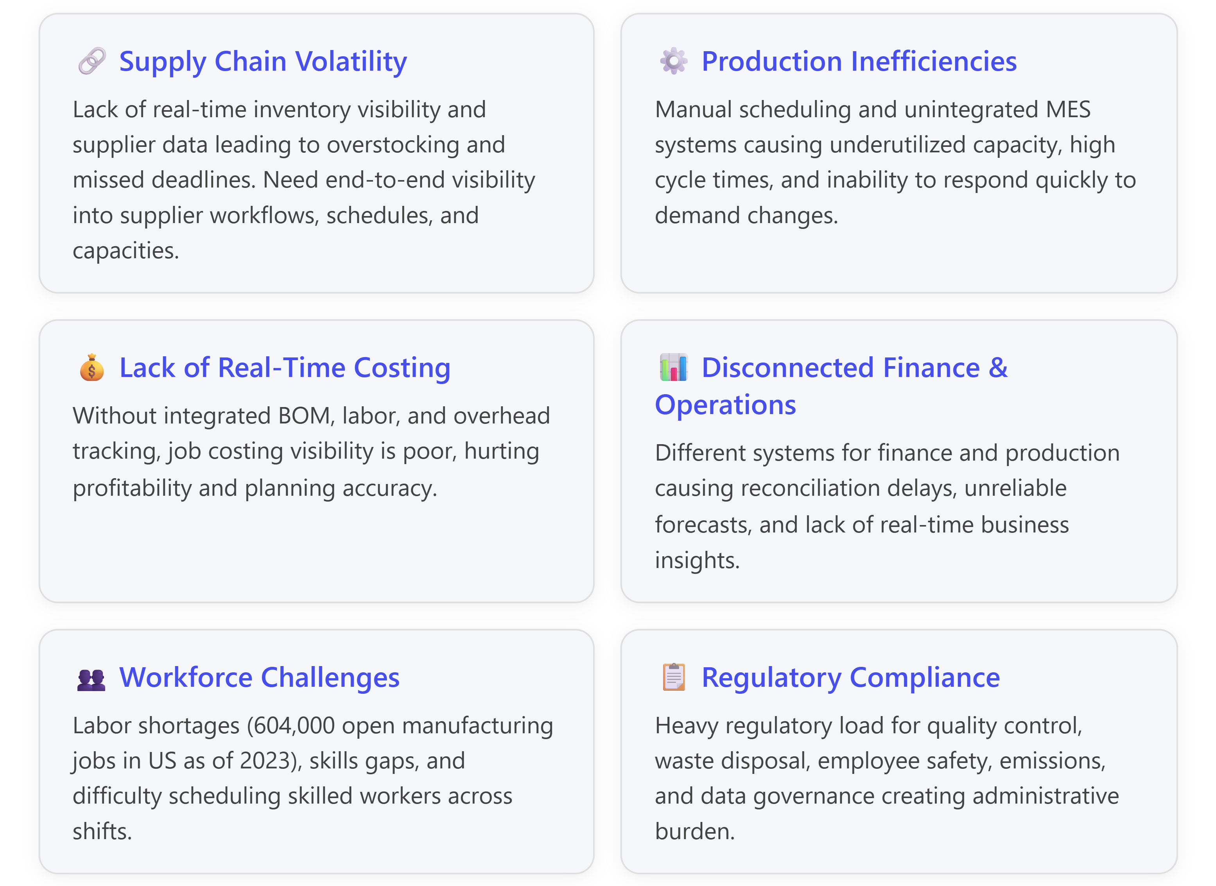

2.2 Required Functional Capabilities
Vendors must propose solutions that include the following modules and capabilities:

2.2.1 Financial Management
- General Ledger: Multi-entity, multi-currency, multi-GAAP support with real-time consolidation
- Accounts Payable/Receivable: Automated invoice processing with AI-powered document recognition
- Cash Management: Bank reconciliation and liquidity monitoring across global operations
- Fixed Assets: Asset lifecycle management with depreciation calculation
- Financial Reporting: Real-time dashboards and regulatory compliance reporting
- Target Outcome: Reduce month-end close from 5 days to 1 day (75% reduction)

2.2.2 Supply Chain Management
- Demand Planning: AI-driven forecasting with machine learning capabilities
- Supply Planning: Material requirements planning (MRP) with demand-driven scheduling
- Inventory Management: Multi-location tracking, ABC classification, safety stock automation, lot/serial control
- Warehouse Management: Real-time inventory visibility, cycle counting, and optimization
- Logistics & Global Trade: Shipping optimization and international trade compliance
- Target Outcome: Reduce inventory carrying costs by 20-25%, improve on-time delivery by 15-20%

2.2.3 Manufacturing Operations
- Work Order Management: Creation, scheduling, and tracking of production work orders
- Production Scheduling: Capacity planning, work center scheduling, and demand-driven MRP
- BOM/Routing Management: Bill of Materials and routing configuration with version control
- Shop Floor Control: Real-time production tracking and labor reporting
- Discrete & Process Manufacturing: Support for both manufacturing methodologies
- Cost Management: Real-time costing with actual vs. standard cost tracking
- Target Outcome: Increase Overall Equipment Effectiveness (OEE) by 15-25%, reduce production cycle time by 20%

2.2.4 Quality Management
- Quality Planning: Inspection plans and quality specifications
- Non-Conformance Tracking: Defect tracking and root cause analysis
- CAPA Management: Corrective and preventive action workflows
- Compliance Management: Regulatory compliance and audit trail capabilities
- Target Outcome: Reduce defect rates by 20-30%, improve first-pass yield by 15%

2.2.5 Procurement & Supplier Management
- Strategic Sourcing: RFx management and supplier evaluation
- Purchase Order Automation: Three-way matching (PO, receipt, invoice)
- Supplier Portal: Self-service capabilities for suppliers
- Contract Management: Contract compliance tracking and renewal management
- Spend Analytics: Real-time visibility into procurement spend
- Target Outcome: Reduce procurement costs by 10-15%, improve contract compliance by 25%

2.2.6 Maintenance Management
- Preventive Maintenance: Scheduled maintenance planning and execution
- Predictive Maintenance: IoT-based monitoring and AI-powered failure prediction
- Work Request Management: Maintenance request tracking and prioritization
- Asset Lifecycle Management: Complete asset history and performance tracking
- Target Outcome: Reduce unplanned downtime by 30-40%, extend equipment life by 15-20%

2.2.7 Human Capital Management (HCM)
- Workforce Management: Shift scheduling for manufacturing workforce
- Time & Labor: Time tracking with integration to payroll and project costing
- Skills Management: Track certifications and skills for compliance and scheduling
- Talent Acquisition: Recruiting and onboarding for manufacturing roles
- Performance Management: Goal setting and performance reviews
- Target Outcome: Reduce time-to-hire by 30%, improve productivity by 15%

3. Oracle Fusion Cloud Capabilities Overview

3.1 Core Platform Advantages
Oracle Fusion Cloud Applications offer unique architectural advantages specifically beneficial to manufacturing organizations:
Cloud-Based Cost Benefits:
- Lower IT Infrastructure Costs: Elimination of on-premises hardware reducing capital expenditures
- Subscription-Based Pricing: Flexible pricing models allowing scaling based on demand
- Automatic Updates: Quarterly automatic updates at no additional cost, unlike competitor solutions requiring $500K-$2M for major upgrades
- Business Continuity: High availability and disaster recovery reducing downtime risks
Unified Architecture:
- Single Database: All modules (ERP, SCM, HCM, CX) operate on one unified database - no data synchronization or batch jobs required
- Real-Time Integration: Inventory levels inform production schedules, which feed financial forecasts and dashboards
- Embedded AI: 50+ AI agents included in base licensing (versus $50-$150/user/month add-on costs with competitors)

3.2 Oracle Fusion Modules - Manufacturing Domain
The following table summarizes Oracle Fusion Cloud modules relevant to manufacturing operations:
Module | Key Features | Manufacturing Pain Points Addressed | Business Value/ROI Potential
Oracle Fusion ERP Cloud - Financials | General Ledger, AP/AR, Cash Management, Fixed Assets, Revenue Management, Real-time Financial Consolidation, Multi-currency/Multi-GAAP support | Disconnected finance & operations, Delayed month-end close, Poor cost visibility, Manual reconciliation processes | Reduce close time by 75% (5 days to 1 day), Improve forecast accuracy by 30%, Enable real-time financial insights
Oracle Supply Chain Management (SCM) Cloud | Demand Planning, Supply Planning, Inventory Optimization, Warehouse Management, Logistics, Global Trade Management, IoT-enabled tracking | Supply chain disruptions, Supplier visibility gaps, Inventory imbalances, Demand forecasting inaccuracy | Reduce inventory carrying costs by 20-25%, Improve on-time delivery by 15-20%, Reduce supply disruptions by 30%
Oracle Manufacturing Cloud | Work Order Management, Production Scheduling, BOM/Routing Management, Shop Floor Control, Discrete & Process Manufacturing, Cost Roll-up | Production inefficiencies, Manual scheduling, Lack of real-time shop floor data, High cycle times, Capacity underutilization | Increase OEE by 15-25%, Reduce production cycle time by 20%, Improve capacity utilization by 10-15%
Oracle Procurement Cloud | Strategic Sourcing, Supplier Qualification, Purchase Orders, Contract Management, Supplier Portal, Spend Analytics | Supplier qualification gaps, Maverick spending, Poor contract compliance, Manual PO processes | Reduce procurement costs by 10-15%, Improve contract compliance by 25%, Reduce maverick spending by 30%
Oracle Maintenance Cloud | Preventive/Predictive Maintenance, Asset Lifecycle Management, Work Request Management, IoT-based Monitoring, Downtime Tracking | Unplanned downtime, High maintenance costs, Aging equipment failures, Reactive maintenance approach | Reduce unplanned downtime by 30-40%, Extend equipment life by 15-20%, Reduce maintenance costs by 20%
Oracle Quality Management | Quality Planning, Inspection Management, Non-conformance Tracking, CAPA (Corrective/Preventive Action), Compliance Management | Product quality issues, Regulatory non-compliance, Customer complaints, Warranty costs, Lack of traceability | Reduce defect rates by 20-30%, Improve first-pass yield by 15%, Reduce warranty costs by 25%
Oracle Inventory Management Cloud | Multi-org Inventory, Lot/Serial Control, Cycle Counting, ABC Analysis, Min-Max Planning, Consignment Inventory | Stock-outs and overstock, Inaccurate inventory counts, Slow-moving inventory, Poor warehouse utilization | Reduce stock-outs by 40%, Improve inventory accuracy to 99%+, Reduce carrying costs by 15-20%
Oracle Order Management Cloud | Order Capture, Order Orchestration, Promising, Fulfillment, Returns Management, Omnichannel Support | Order fulfillment delays, Inaccurate promising, Poor customer visibility, Returns processing inefficiency | Improve order fill rate by 20%, Reduce order cycle time by 30%, Increase customer satisfaction by 25%
Oracle Project Portfolio Management (PPM) | Project Costing, Resource Management, Project Billing, Portfolio Analysis, Grants Management | Project cost overruns, Resource allocation issues, Billing delays, Portfolio visibility gaps | Reduce project overruns by 20%, Improve resource utilization by 15%, Accelerate billing by 40%
Oracle HCM Cloud - Workforce Management | Shift Scheduling, Time & Labor Tracking, Skills Management, Talent Acquisition, Performance Management | Labor shortages, Skills gaps, Inefficient scheduling, Poor workforce productivity, High turnover | Reduce time-to-hire by 30%, Improve productivity by 15%, Reduce overtime costs by 20%
Note: ROI estimates based on industry benchmarks from Oracle customer implementations and analyst reports (2024-2025)

4. Implementation Approach

4.1 Preferred Implementation Methodology
Vendors must propose an implementation methodology aligned with Oracle Fusion Cloud best practices. The preferred approach includes the following phases:
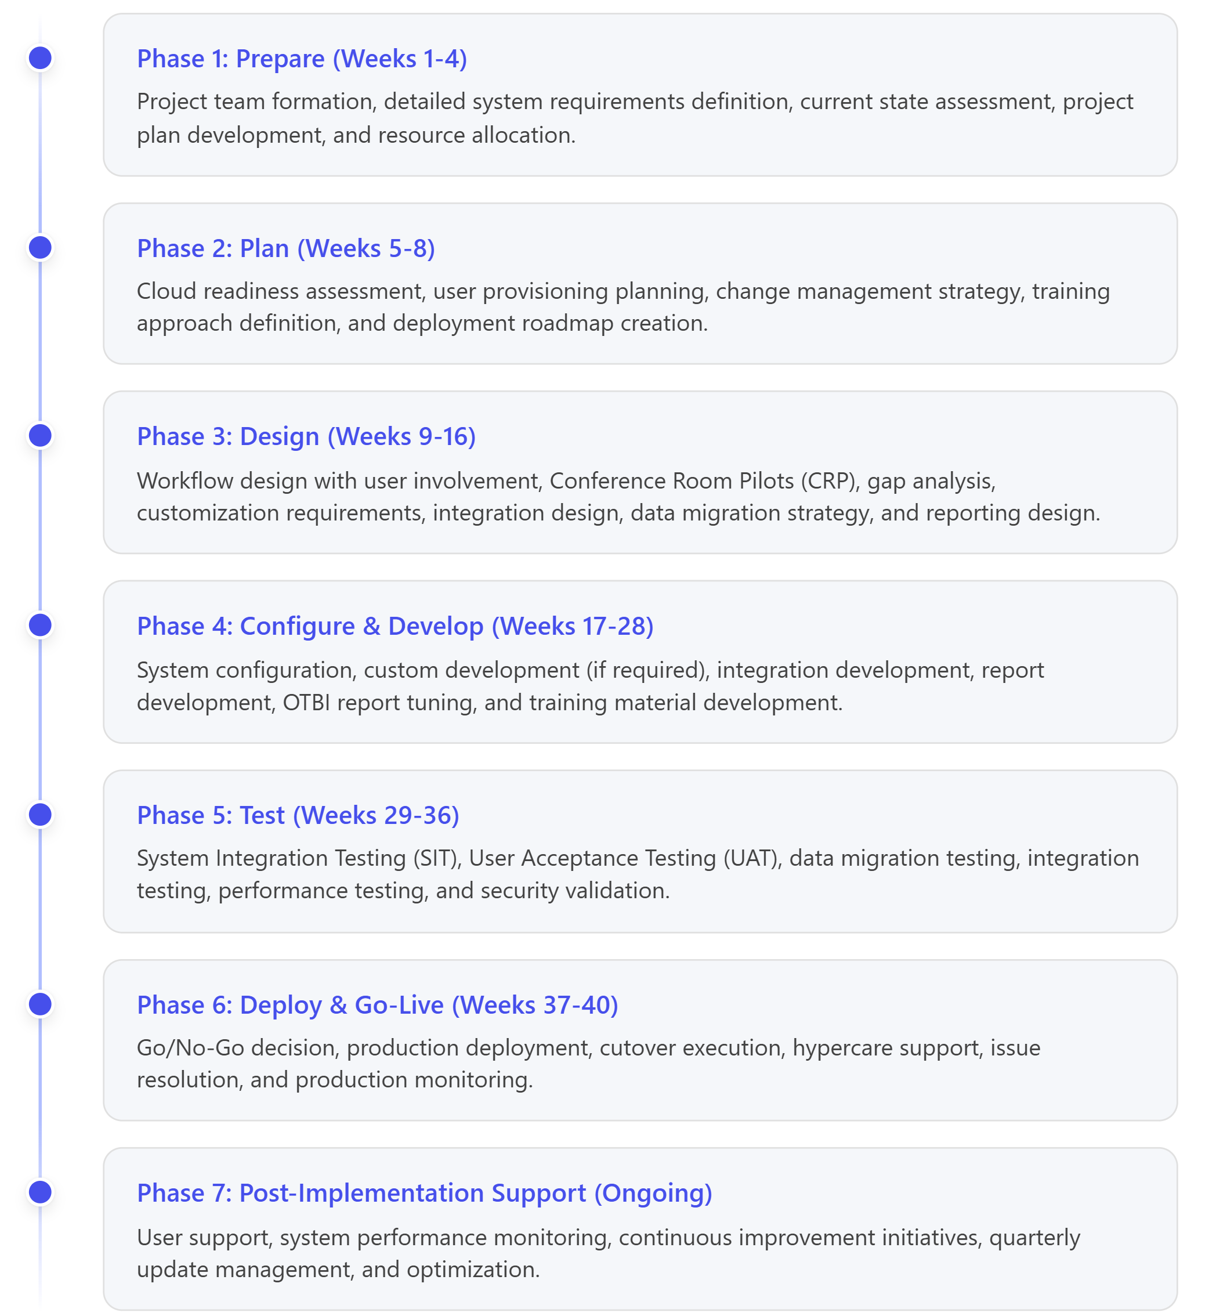

4.2 Implementation Timeline Requirements
- Total Implementation Duration: 6-12 months from project kickoff to go-live
- Phased Rollout Option: Vendors should provide options for phased implementation by module
- Pilot Implementation: Option to pilot in one manufacturing facility before enterprise-wide rollout
- Training Duration: Minimum 4 weeks of comprehensive role-based training before go-live

4.3 Change Management & User Adoption
Vendor proposals must include robust change management strategies :
- Executive Sponsorship: Mechanisms to obtain and maintain executive buy-in
- Communication Plan: Regular communication to employees about benefits and timelines
- Training Programs: Role-based training including:
  - End-user functional training
  - Technical training for IT staff
  - Train-the-trainer programs
  - Self-service learning portals
- User Adoption Metrics: KPIs to measure user adoption and system utilization
- Support Structure: Help desk, power users, and ongoing support resources

5. Integration Requirements

5.1 Integration Architecture
Oracle Fusion Cloud Applications must integrate seamlessly with existing and future enterprise systems. Vendors must propose comprehensive integration strategies.

5.1.1 Integration Technologies
Acceptable integration approaches include:
- Oracle Integration Cloud (OIC): Native Oracle cloud integration platform
- REST APIs: Oracle Fusion Cloud REST API services
- SOAP Web Services: For legacy system integration
- File-Based Integration: Flat files, CSV, XML for batch data exchange
- Oracle SOA Suite: For complex orchestration scenarios
- Middleware Platforms: MuleSoft, Dell Boomi, or other certified middleware

5.1.2 Required Integrations
Integration Type | Source System | Target System | Integration Method | Frequency
Manufacturing Execution System (MES) | Shop Floor MES | Oracle Manufacturing Cloud | Real-time REST API | Real-time
IoT Equipment Data | IoT Sensors/Controllers | Oracle Maintenance Cloud | IoT Gateway → OIC | Real-time/Streaming
Quality Inspection Results | Quality Management System | Oracle Quality Management | REST API / Batch | Near real-time
Product Lifecycle Management | PLM System | Oracle Manufacturing (BOM/Routing) | File-based / REST API | Daily
Warehouse Management | WMS | Oracle Inventory Management | REST API | Real-time
E-Commerce Platform | Web Store | Oracle Order Management | REST API | Real-time
Third-Party Logistics | 3PL Systems | Oracle SCM/Logistics | EDI / REST API | Hourly
Banking Systems | Bank Portal | Oracle Cash Management | File-based (BAI2/MT940) | Daily
Tax Compliance | Tax Software | Oracle Financials | REST API | Monthly
Business Intelligence | Oracle Analytics Cloud | All Oracle Fusion Modules | Native OAC Connector | Real-time

5.1.3 Integration Testing
Vendors must include comprehensive integration testing:
- Point-to-point integration testing for each interface
- End-to-end process testing across integrated systems
- Error handling and exception management validation
- Performance and volume testing
- Security and authentication testing

6. Data Migration Strategy

6.1 Data Migration Requirements
Vendors must propose a comprehensive data migration approach :

6.1.1 Data Scope
The following master and transactional data must be migrated:
Master Data:
- Chart of Accounts (GL structure)
- Customers and customer sites
- Suppliers and supplier sites
- Items (materials, finished goods, components)
- Bills of Material (BOM) and routings
- Employees and organizational hierarchy
- Fixed assets
- Price lists and pricing rules
- Tax codes and rules
Transactional Data (selective migration):
- Open purchase orders
- Open sales orders
- Work orders in progress
- Open AP/AR balances
- Inventory on-hand balances
- Year-to-date financial transactions (current fiscal year)
Historical Data:
- Define retention requirements (recommend 3 years minimum)
- Archive strategy for data not migrated

6.1.2 Data Migration Approach
- Data Quality Assessment: Discover errors and gaps in current systems before migration
- Data Cleansing: Resolve data quality issues in source systems
- Data Mapping: Detailed mapping documents from source to Oracle Fusion Cloud data models
- Migration Tools: Use Oracle-certified data migration tools (FBDI, ADFdi, ADFDI)
- Validation & Reconciliation: Automated reconciliation reports comparing source vs. target data
- Phased Migration: Recommend phased approach (master data first, then transactional)
- Cutover Strategy: Detailed cutover plan with rollback procedures

6.2 Data Migration Testing
- Unit Testing: Test each data entity migration independently
- Integration Testing: Test dependencies between data entities
- Mock Cutover: Full dress rehearsal of go-live cutover
- Production Validation: Post go-live data reconciliation and validation

7. ROI Expectations & Success Metrics

7.1 Expected Return on Investment
Based on industry benchmarks and Oracle Fusion Cloud customer implementations, we expect the following ROI outcomes :
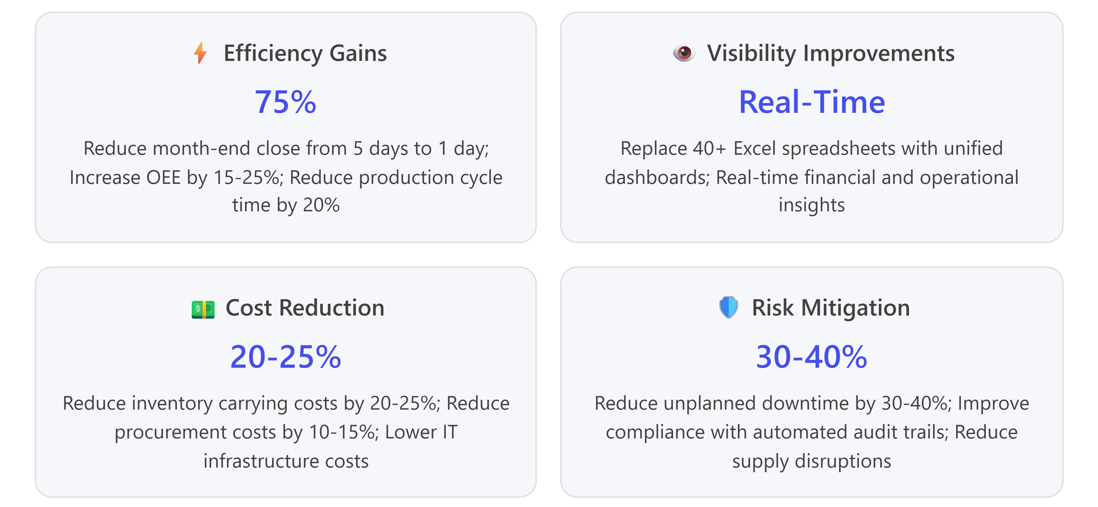

7.2 Success Metrics & KPIs
Vendors must propose measurable KPIs to track implementation success and ongoing value realization:

7.2.1 Financial Metrics
- Month-End Close Time: Target reduction from 5 days to 1 day (75% improvement)
- Forecast Accuracy: Improve financial forecast accuracy by 30%
- Days Sales Outstanding (DSO): Reduce by 15-20%
- Accounts Payable Processing Cost: Reduce cost per invoice by 40%
- Cash Visibility: Real-time cash position across all entities

7.2.2 Operational Metrics
- Overall Equipment Effectiveness (OEE): Increase from current baseline by 15-25%
- Production Cycle Time: Reduce by 20%
- On-Time Delivery (OTD): Improve by 15-20%
- Inventory Accuracy: Achieve 99%+ accuracy
- Stock-Out Incidents: Reduce by 40%
- Production Schedule Adherence: Achieve 95%+ adherence

7.2.3 Quality Metrics
- First-Pass Yield: Improve by 15%
- Defect Rate: Reduce by 20-30%
- Customer Complaints: Reduce by 25%
- Warranty Costs: Reduce by 25%
- Quality Inspection Time: Reduce by 30%

7.2.4 Procurement & Supply Chain Metrics
- Procurement Costs: Reduce by 10-15%
- Supplier On-Time Delivery: Improve to 95%+
- Purchase Order Cycle Time: Reduce by 30%
- Maverick Spending: Reduce by 30%
- Contract Compliance: Improve by 25%

7.2.5 Maintenance Metrics
- Unplanned Downtime: Reduce by 30-40%
- Mean Time Between Failures (MTBF): Increase by 20%
- Maintenance Costs: Reduce by 20%
- Preventive Maintenance Completion: Achieve 95%+ on-time completion

7.2.6 Workforce Metrics
- Time-to-Hire: Reduce by 30%
- Employee Productivity: Improve by 15%
- Overtime Costs: Reduce by 20%
- Workforce Utilization: Improve by 10-15%

7.3 ROI Calculation Methodology
Vendors must provide:
- TCO Analysis: 5-year Total Cost of Ownership including licensing, implementation, ongoing support, and training
- ROI Model: Quantified benefits (efficiency, cost reduction, risk mitigation) versus total investment
- Payback Period: Expected time to achieve positive ROI
- Net Present Value (NPV): Discounted cash flow analysis over 5 years

8. Vendor Qualifications & Requirements

8.1 Mandatory Qualifications
Vendors responding to this RFP must demonstrate the following qualifications:

8.1.1 Oracle Partnership Status
- Oracle Platinum Partner (preferred) or Oracle Gold Partner (minimum)
- Oracle Cloud Excellence Implementer (OCEI) designation
- Oracle Cloud Standard or Premier Support certified

8.1.2 Manufacturing Industry Experience
- Minimum 5 Oracle Fusion Cloud ERP implementations in manufacturing industry (discrete or process)
- At least 3 implementations of similar size and complexity to our organization
- Experience with both greenfield implementations and migrations from legacy ERP systems

8.1.3 Technical Certifications
Implementation team must include certified resources:
- Oracle Fusion Cloud ERP Certified Implementation Specialists (minimum 3)
- Oracle Fusion Cloud SCM Certified Implementation Specialists (minimum 2)
- Oracle Fusion Cloud Manufacturing Certified Implementation Specialists (minimum 2)
- Oracle Integration Cloud (OIC) Certified Specialists (minimum 2)
- Oracle HCM Cloud Certified Implementation Specialists (minimum 1)

8.1.4 Project Management Credentials
- Project Manager with PMP (Project Management Professional) certification
- Experience with Agile/Scrum methodologies for cloud implementations

8.2 Vendor Proposal Requirements

8.2.1 Company Information
- Company overview, history, and ownership structure
- Oracle partnership details and certifications
- Financial stability documentation (Dun & Bradstreet report or equivalent)
- Geographic presence and support capabilities

8.2.2 Experience & References
- Case Studies: Minimum 3 detailed case studies of Oracle Fusion Cloud implementations in manufacturing
  - Company profile (size, industry sub-sector)
  - Modules implemented
  - Implementation timeline and budget
  - Challenges encountered and resolutions
  - Quantified business outcomes achieved
- Client References: Minimum 5 verifiable client references
  - Contact information (name, title, phone, email)
  - Project details and outcomes
  - Client satisfaction rating

8.2.3 Implementation Team
- Organizational Chart: Proposed project organizational structure
- Team Resumes: Detailed resumes including:
  - Oracle certifications
  - Years of experience with Oracle Fusion Cloud
  - Previous manufacturing implementations
  - Availability and allocation percentage for this project
- Resource Plan: Estimated resource loading by phase and role
- Knowledge Transfer Plan: Approach to build internal client capabilities

8.2.4 Technical Approach
- Implementation Methodology: Detailed description aligned with Section 4.1
- Module Implementation Sequence: Recommended phasing and sequencing
- Integration Architecture: Approach per Section 5
- Data Migration Strategy: Approach per Section 6
- Testing Strategy: Comprehensive testing approach (SIT, UAT, performance, security)
- Go-Live Strategy: Cutover planning and hypercare support approach

8.2.5 Change Management & Training
- Change Management Approach: Strategy to drive user adoption
- Training Curriculum: Role-based training programs
- Training Delivery Methods: Classroom, virtual, e-learning, train-the-trainer
- Training Materials: Sample training materials and documentation
- Support Model: Post go-live support structure and service level agreements

8.2.6 Post-Implementation Support
- Application Managed Services (AMS): Ongoing support model, SLAs, and pricing
- Quarterly Update Management: Approach to manage Oracle's quarterly cloud updates
- Continuous Improvement: Strategy for ongoing optimization and enhancements
- Support Coverage: Geographic coverage, hours of operation, escalation procedures

9. Pricing & Commercial Terms

9.1 Pricing Structure
Vendors must provide transparent, detailed pricing including:

9.1.1 Software Licensing
- Oracle Fusion Cloud Subscription Costs:
  - Licensing costs by module (ERP, SCM, Manufacturing, HCM, etc.)
  - User-based pricing (number of users by module)
  - Subscription term (annual, multi-year discounts)
  - Price escalation terms
- Third-Party Software (if required):
  - Integration middleware licensing
  - Analytics/BI tools beyond Oracle Analytics Cloud
  - Any other required third-party applications

9.1.2 Implementation Services
- Professional Services Fees:
  - Implementation services (by phase or total project)
  - Hourly rates by resource role (Project Manager, Functional Consultant, Technical Consultant, etc.)
  - Fixed-fee pricing (preferred) versus time-and-materials
  - Change order rates for out-of-scope work
- Data Migration Services: Separate pricing for data migration activities
- Integration Development: Pricing per integration interface
- Custom Development: Pricing for any required customizations
- Training Services: Pricing per training type and delivery method

9.1.3 Ongoing Support & Maintenance
- Oracle Cloud Support Fees: Annual support costs (typically percentage of subscription)
- Application Managed Services (AMS): Monthly or annual support pricing
- Quarterly Update Support: Costs for managing Oracle's quarterly updates
- Enhancement Services: Retainer or hourly rates for ongoing enhancements

9.1.4 Other Costs
- Travel & Expenses: Estimated travel costs for on-site work
- Hardware/Infrastructure: Any required hardware (servers, network equipment, etc.)
- Testing Environments: Costs for development, test, and training instances
- Documentation: Costs for documentation and knowledge transfer materials

9.2 Payment Terms
- Proposed payment milestone structure aligned with project phases
- Retention percentage (recommend 10-15% held until successful go-live)
- Payment terms (Net 30, Net 45, etc.)
- Warranty period and terms

9.3 Commercial Terms
- Contract Duration: Initial term and renewal options
- Service Level Agreements (SLAs): Uptime guarantees, response times, resolution times
- Termination Clauses: Terms for early termination
- Liability Caps: Limitation of liability provisions
- Intellectual Property: Ownership of customizations, configurations, and documentation
- Confidentiality: Data security and confidentiality requirements

10. Evaluation Criteria

10.1 Proposal Evaluation Methodology
Proposals will be evaluated using a weighted scoring methodology. The total possible score is 1000 points distributed as follows:
Evaluation Category | Weight | Maximum Points | Key Evaluation Factors
Technical Approach & Methodology | 25% | 250 | Implementation methodology alignment with best practices, phased approach, testing strategy, data migration approach, integration architecture, go-live strategy
Vendor Qualifications & Experience | 20% | 200 | Oracle partnership level, manufacturing implementation experience, client references, team certifications, financial stability, company reputation
Implementation Team | 15% | 150 | Team experience with Oracle Fusion Cloud, manufacturing expertise, resource availability, certifications, knowledge transfer approach
Functional Fit | 15% | 150 | Ability to meet business requirements (Section 2.2), module coverage, manufacturing-specific capabilities, customization requirements (lower is better)
Pricing & Value | 15% | 150 | Total cost of ownership (TCO), pricing transparency and competitiveness, payment terms, licensing costs, ongoing support costs
ROI & Success Metrics | 10% | 100 | ROI model credibility, quantified benefits, success metric tracking approach, KPI alignment with Section 7.2
Post-Implementation Support | 5% | 50 | AMS model, SLA commitments, quarterly update management, continuous improvement approach, support coverage
Innovation & Differentiation | 5% | 50 | Use of AI/ML capabilities, IoT integration, industry-specific innovations, unique value propositions
Total Maximum Score: 1000 points

10.2 Evaluation Process
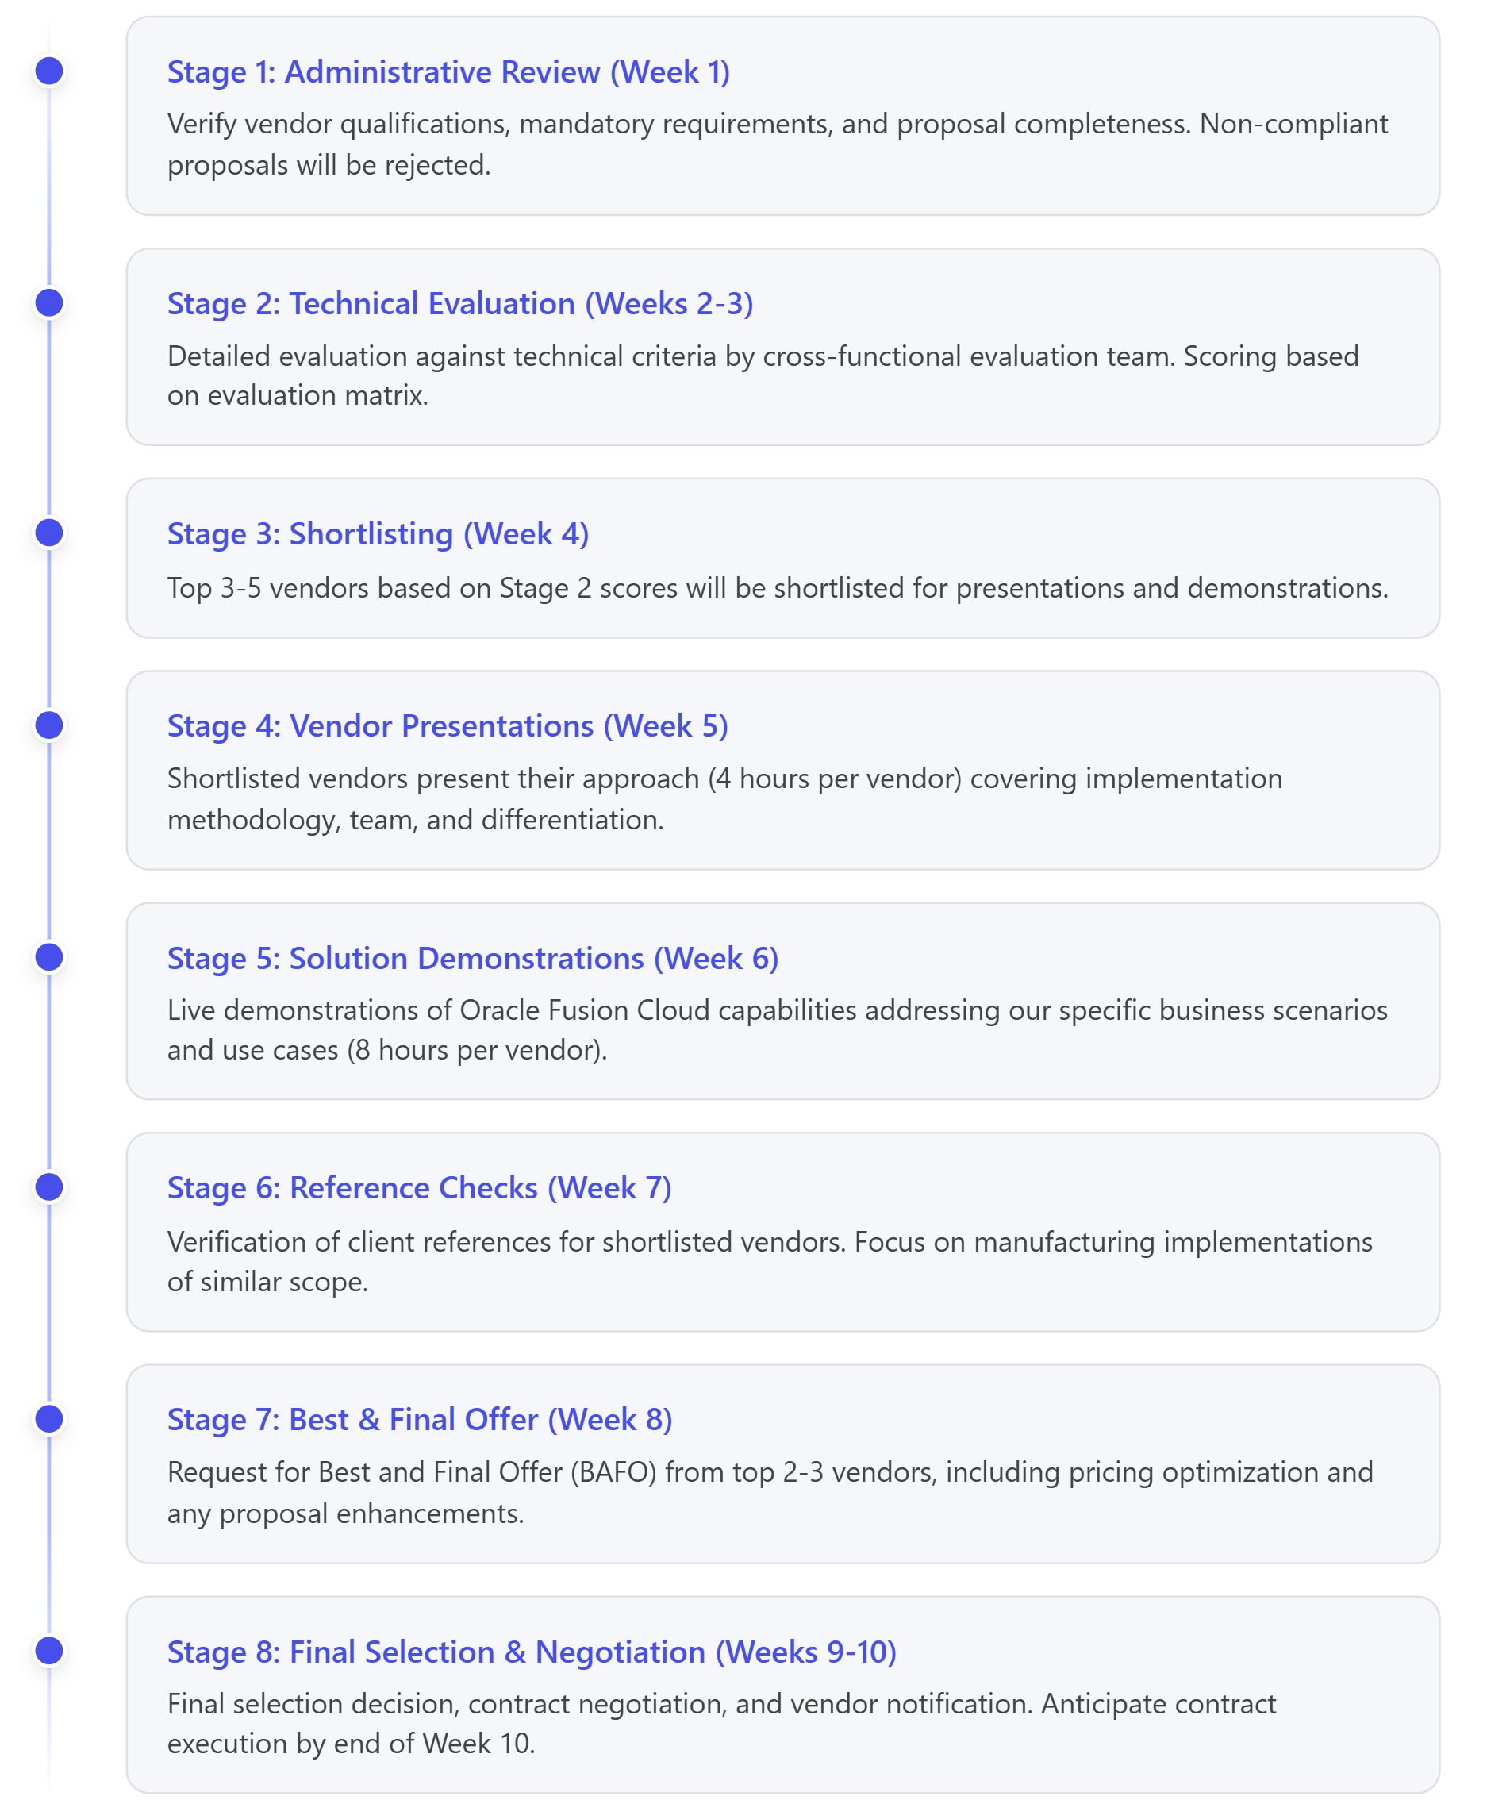

10.3 Selection Criteria Details

10.3.1 Technical Approach (250 points)
- Implementation Methodology (80 pts): Alignment with Oracle best practices, phased approach, risk mitigation
- Integration Architecture (50 pts): Comprehensive integration strategy, use of Oracle Integration Cloud, API-first approach
- Data Migration Strategy (40 pts): Data quality assessment, migration tools, validation approach
- Testing Strategy (40 pts): SIT, UAT, integration testing, performance testing, regression testing
- Go-Live & Cutover Planning (40 pts): Detailed cutover plan, rollback procedures, hypercare support

10.3.2 Vendor Qualifications (200 points)
- Oracle Partnership Status (50 pts): Platinum Partner (50 pts), Gold Partner (35 pts), other (0 pts)
- Manufacturing Experience (70 pts): Number of similar implementations, complexity, success rate
- Client References (40 pts): Quality and relevance of references, client satisfaction scores
- Financial Stability (20 pts): Dun & Bradstreet rating, revenue stability, company longevity
- Company Reputation (20 pts): Industry awards, analyst recognition, thought leadership

10.3.3 Implementation Team (150 points)
- Team Certifications (50 pts): Number and relevance of Oracle Fusion Cloud certifications
- Manufacturing Expertise (40 pts): Years of experience in manufacturing, number of implementations
- Resource Availability (30 pts): Dedicated resources, allocation percentage, bench strength
- Knowledge Transfer (30 pts): Approach to build internal capabilities, documentation quality

10.3.4 Functional Fit (150 points)
- Requirements Coverage (80 pts): Percentage of business requirements met out-of-the-box
- Manufacturing Capabilities (40 pts): Depth of manufacturing-specific functionality
- Minimal Customization (30 pts): Ability to meet requirements with standard configuration (fewer customizations scored higher)

10.3.5 Pricing & Value (150 points)
- Total Cost of Ownership (60 pts): Competitiveness of 5-year TCO
- Pricing Transparency (30 pts): Clarity and detail of pricing breakdown
- Payment Terms (30 pts): Favorable payment milestones and retention terms
- Licensing Costs (30 pts): Competitiveness of Oracle subscription costs

10.3.6 ROI & Success Metrics (100 points)
- ROI Model (50 pts): Credibility of financial model, quantified benefits, payback period
- Success Metrics (30 pts): KPI tracking approach, dashboard and reporting capabilities
- Benchmarking (20 pts): Use of industry benchmarks and best practices

10.3.7 Post-Implementation Support (50 points)
- AMS Model (20 pts): Comprehensiveness of ongoing support, SLA commitments
- Quarterly Updates (15 pts): Approach to managing Oracle's quarterly updates
- Continuous Improvement (15 pts): Strategy for ongoing optimization and value realization

10.3.8 Innovation & Differentiation (50 points)
- AI/ML Utilization (20 pts): Use of Oracle's AI agents, predictive capabilities
- IoT Integration (15 pts): Approach to integrating IoT sensors and equipment data
- Unique Value Propositions (15 pts): Accelerators, tools, IP that differentiate the vendor

11. RFP Response Instructions

11.1 Proposal Submission Requirements

11.1.1 Proposal Format
- Document Format: PDF format, bookmarked for easy navigation
- Page Limit: Maximum 150 pages (excluding appendices)
- Font: Minimum 11-point font, clear and readable
- Executive Summary: Maximum 5 pages summarizing key points
- Table of Contents: Detailed table of contents with page numbers

11.1.2 Required Sections
Proposals must include the following sections in order:
- Executive Summary (5 pages max)
- Company Overview (Section 8.2.1)
- Experience & References (Section 8.2.2)
- Implementation Team (Section 8.2.3)
- Technical Approach (Section 8.2.4)
- Change Management & Training (Section 8.2.5)
- Post-Implementation Support (Section 8.2.6)
- Pricing (Section 9)
- Appendices:
  - Detailed team resumes
  - Case studies (minimum 3)
  - Client reference contacts (minimum 5)
  - Oracle partnership certificates
  - Team certifications
  - Sample deliverables (project plan, training materials, etc.)

11.1.3 Proposal Questions
Vendors must respond to the following questions in their proposal:
- Describe your implementation methodology for Oracle Fusion Cloud ERP in manufacturing environments.
- How do you approach Conference Room Pilots (CRPs) and gap analysis?
- Describe your data migration approach, tools, and data quality assurance process.
- How do you manage integration with existing systems (MES, PLM, WMS, etc.)?
- What is your approach to change management and user adoption?
- Describe your training delivery methods and curriculum.
- How do you handle Oracle's quarterly cloud updates post go-live?
- What differentiates your Oracle Fusion Cloud practice from competitors?
- Describe a challenging Oracle Fusion Cloud implementation in manufacturing and how you resolved issues.
- How do you track and measure ROI and success metrics post-implementation?

11.2 Submission Instructions

11.2.1 Proposal Deadline
Proposals must be received by: 5:00 PM [Local Time] on May 27, 2026
Late proposals will not be accepted.

11.2.2 Submission Method
Submit proposals electronically to:
Email: [procurement@clientcompany.com] Subject Line: "RFP Response - Oracle Fusion Cloud Implementation - [Vendor Name]"
Electronic submissions must include:
- Main proposal document (PDF)
- Pricing spreadsheet (Excel format)
- All appendices (PDF)
- Signed Non-Disclosure Agreement (NDA) if required

11.2.3 Questions & Clarifications
Vendors may submit questions about this RFP:
Deadline for Questions: April 30, 2026, 5:00 PM [Local Time] Submit Questions To: [procurement@clientcompany.com] Responses Published: May 7, 2026
All questions and answers will be published to all vendors to ensure fairness.

11.3 Proposal Terms & Conditions
- Proposal Validity: Proposals must remain valid for 120 days from submission deadline
- Confidentiality: All information submitted will be treated as confidential
- No Obligation: This RFP does not commit the client to award a contract
- Right to Reject: Client reserves the right to reject any or all proposals
- Cost of Proposal: Vendors bear all costs associated with proposal preparation
- Ownership: All proposals submitted become property of the client

12. Key Dates & Timeline
Milestone | Date | Description
RFP Issued | April 13, 2026 | RFP released to qualified vendors
Vendor Questions Deadline | April 30, 2026 | Deadline for vendor questions and clarifications
Responses to Questions | May 7, 2026 | Client publishes answers to vendor questions
Proposal Submission Deadline | May 27, 2026, 5:00 PM | Final deadline for proposal submission
Administrative Review | Week of June 2, 2026 | Verify proposal completeness and qualifications
Technical Evaluation | June 9-20, 2026 | Detailed evaluation against criteria
Shortlist Notification | June 23, 2026 | Top vendors notified for presentations
Vendor Presentations | Week of June 30, 2026 | Shortlisted vendors present approach (4 hours each)
Solution Demonstrations | Week of July 7, 2026 | Live Oracle Fusion Cloud demonstrations (8 hours each)
Reference Checks | Week of July 14, 2026 | Verification of client references
Best & Final Offer (BAFO) | July 21, 2026 | Request for final pricing and proposal refinements
Final Selection | July 28, 2026 | Vendor selection decision
Contract Negotiation | August 4-15, 2026 | Contract negotiation and finalization
Contract Execution | August 22, 2026 | Signed contract and project kickoff
Implementation Start | September 2, 2026 | Project kickoff and Phase 1 initiation

13. Contact Information
For questions, clarifications, or submission of proposals, please contact:
Primary Contact:
[Name]
[Title]
[Company Name]
[Email]
[Phone]
Secondary Contact:
[Name]
[Title]
[Company Name]
[Email]
[Phone]
Mailing Address:
[Company Name]
[Street Address]
[City, State, ZIP]

14. Appendices

Appendix A: Current IT Landscape
[Include details about current ERP system, version, modules in use, number of users, etc.]

Appendix B: Organizational Structure
[Include organizational chart showing business units, manufacturing facilities, geographic locations]

Appendix C: Data Volume Estimates
[Include estimated data volumes: number of customers, suppliers, items, BOMs, transactions per month, etc.]

Appendix D: Glossary of Terms
Term | Definition
AMS | Application Managed Services - ongoing support for Oracle Fusion Cloud applications
BAFO | Best and Final Offer - final pricing submission from shortlisted vendors
BOM | Bill of Materials - list of raw materials, components, and assemblies required to manufacture a product
CRP | Conference Room Pilot - interactive sessions demonstrating system functionality to users
FBDI | File-Based Data Import - Oracle's recommended approach for bulk data loading
OEE | Overall Equipment Effectiveness - manufacturing KPI measuring equipment performance
OIC | Oracle Integration Cloud - Oracle's cloud-based integration platform
OTBI | Oracle Transactional Business Intelligence - out-of-the-box reporting in Oracle Fusion Cloud
SCM | Supply Chain Management - processes and systems managing supply chain from suppliers to customers
SIT | System Integration Testing - testing of integrated system components
UAT | User Acceptance Testing - testing by end users to validate system meets requirements

Appendix E: Sample Integration Scenarios
[Include detailed description of 2-3 key integration scenarios for vendor understanding]

Appendix F: Sample Business Processes
[Include flowcharts or narratives of critical business processes: procure-to-pay, order-to-cash, manufacturing work order execution]

15. Signature & Acknowledgment
By submitting a proposal in response to this RFP, the vendor acknowledges:
- Receipt and understanding of all RFP requirements
- Agreement to the terms and conditions outlined in Section 11.3
- Certification that all information provided is accurate and complete
- Commitment to the proposed pricing for the validity period
- Willingness to enter into good faith contract negotiations if selected

Vendor Company Name: ___________________________________
Authorized Signatory Name: ___________________________________
Title: ___________________________________
Signature: ___________________________________
Date: ___________________________________

End of Request for Proposal
Document Reference: MFG-OFC-2026-001
Issue Date: April 13, 2026
Proposal Deadline: May 27, 2026, 5:00 PM
For questions: [procurement@clientcompany.com]

Citations & References
This RFP was developed using the following authoritative sources:
- Oracle Fusion Cloud SCM Implementation Guide (25C)
- Oracle ERP Manufacturing Pain Points Analysis
- Oracle ERP in Manufacturing: 2025 Guide
- Maximizing ROI with Oracle Fusion Applications
- Oracle Fusion Cloud ERP Modules Reference Guide (2025)
- Oracle ERP Cloud Implementation Best Practices
- Oracle Competitive Intelligence Analysis (Internal Document)
All ROI estimates and industry benchmarks are based on published Oracle customer case studies, analyst reports (Gartner, IDC, Forrester), and industry research from 2024-2025.

https://www.oracle.com/industrial-manufacturing/industrial-manufacturing-pain-points/
https://oracle.teknobgt.com/oracle-erp-manufacturing
https://oracle.teknobgt.com/oracle-erp-manufacturing
https://oracle.teknobgt.com/oracle-erp-manufacturing
https://oracle.teknobgt.com/oracle-erp-manufacturing
https://ltimindtree-my.sharepoint.com/personal/gudurinaveen_10709858_ltimindtree_com/_layouts/15/Doc.aspx?sourcedoc=%7B99C9FE73-0E02-460D-84A4-969929718EE5%7D\&file=Oracle%20Competitor%20offering%20Analysis.docx\&action=default\&mobileredirect=true
https://ltimindtree-my.sharepoint.com/personal/gudurinaveen_10709858_ltimindtree_com/_layouts/15/Doc.aspx?sourcedoc=%7B99C9FE73-0E02-460D-84A4-969929718EE5%7D\&file=Oracle%20Competitor%20offering%20Analysis.docx\&action=default\&mobileredirect=true
https://ltimindtree-my.sharepoint.com/personal/gudurinaveen_10709858_ltimindtree_com/_layouts/15/Doc.aspx?sourcedoc=%7B99C9FE73-0E02-460D-84A4-969929718EE5%7D\&file=Oracle%20Competitor%20offering%20Analysis.docx\&action=default\&mobileredirect=true
https://www.oracle.com/industrial-manufacturing/industrial-manufacturing-pain-points/
https://cloud-vantage.com/2025/04/01/maximizing-roi-with-oracle-fusion-applications-a-guide-for-enterprises/
https://www.erpresearch.com/en-us/oracle-erp-cloud-modules
https://oracle.teknobgt.com/oracle-erp-manufacturing
https://www.oracle.com/industrial-manufacturing/industrial-manufacturing-pain-points/
https://oracle.teknobgt.com/oracle-erp-manufacturing
https://oracle.teknobgt.com/oracle-erp-manufacturing
https://www.erpresearch.com/en-us/oracle-erp-cloud-modules
https://oracle.teknobgt.com/oracle-erp-manufacturing
https://www.oracle.com/industrial-manufacturing/industrial-manufacturing-pain-points/
https://ltimindtree-my.sharepoint.com/personal/gudurinaveen_10709858_ltimindtree_com/_layouts/15/Doc.aspx?sourcedoc=%7B99C9FE73-0E02-460D-84A4-969929718EE5%7D\&file=Oracle%20Competitor%20offering%20Analysis.docx\&action=default\&mobileredirect=true
https://www.oracle.com/industrial-manufacturing/industrial-manufacturing-pain-points/
https://cloud-vantage.com/2025/04/01/maximizing-roi-with-oracle-fusion-applications-a-guide-for-enterprises/
https://ltimindtree-my.sharepoint.com/personal/gudurinaveen_10709858_ltimindtree_com/_layouts/15/Doc.aspx?sourcedoc=%7B99C9FE73-0E02-460D-84A4-969929718EE5%7D\&file=Oracle%20Competitor%20offering%20Analysis.docx\&action=default\&mobileredirect=true
https://ltimindtree-my.sharepoint.com/personal/gudurinaveen_10709858_ltimindtree_com/_layouts/15/Doc.aspx?sourcedoc=%7B99C9FE73-0E02-460D-84A4-969929718EE5%7D\&file=Oracle%20Competitor%20offering%20Analysis.docx\&action=default\&mobileredirect=true
https://oracle.teknobgt.com/oracle-erp-manufacturing
https://ltimindtree-my.sharepoint.com/personal/gudurinaveen_10709858_ltimindtree_com/_layouts/15/Doc.aspx?sourcedoc=%7B99C9FE73-0E02-460D-84A4-969929718EE5%7D\&file=Oracle%20Competitor%20offering%20Analysis.docx\&action=default\&mobileredirect=true
https://oracle.teknobgt.com/oracle-erp-manufacturing
https://www.oracle.com/industrial-manufacturing/industrial-manufacturing-pain-points/
https://cloud-vantage.com/2025/04/01/maximizing-roi-with-oracle-fusion-applications-a-guide-for-enterprises/
https://hexaware.com/blogs/oracle-erp-cloud-implementation/
https://ltimindtree-my.sharepoint.com/personal/gudurinaveen_10709858_ltimindtree_com/_layouts/15/Doc.aspx?sourcedoc=%7B99C9FE73-0E02-460D-84A4-969929718EE5%7D\&file=Oracle%20Competitor%20offering%20Analysis.docx\&action=default\&mobileredirect=true
https://cloud-vantage.com/2025/04/01/maximizing-roi-with-oracle-fusion-applications-a-guide-for-enterprises/
https://hexaware.com/blogs/oracle-erp-cloud-implementation/
https://hexaware.com/blogs/oracle-erp-cloud-implementation/
https://hexaware.com/blogs/oracle-erp-cloud-implementation/
https://hexaware.com/blogs/oracle-erp-cloud-implementation/
https://cloud-vantage.com/2025/04/01/maximizing-roi-with-oracle-fusion-applications-a-guide-for-enterprises/
https://oracle.teknobgt.com/oracle-erp-manufacturing
https://www.oracle.com/industrial-manufacturing/industrial-manufacturing-pain-points/
https://docs.oracle.com/en/cloud/saas/supply-chain-and-manufacturing/25c/fammi/getting-started-with-your-manufacturing-and-supply-chain-materials-management-implementation.pdf
https://www.oracle.com/industrial-manufacturing/industrial-manufacturing-pain-points/
https://oracle.teknobgt.com/oracle-erp-manufacturing
https://cloud-vantage.com/2025/04/01/maximizing-roi-with-oracle-fusion-applications-a-guide-for-enterprises/
https://www.erpresearch.com/en-us/oracle-erp-cloud-modules
https://hexaware.com/blogs/oracle-erp-cloud-implementation/
https://ltimindtree-my.sharepoint.com/personal/gudurinaveen_10709858_ltimindtree_com/_layouts/15/Doc.aspx?sourcedoc=%7B99C9FE73-0E02-460D-84A4-969929718EE5%7D\&file=Oracle%20Competitor%20offering%20Analysis.docx\&action=default\&mobileredirect=true

